Getting Started   
ПОЧАТОК РОБОТИ

В руководстве пользователя «Начало работы» описывается установка MDK, всех компонентов продукта и полного рабочего процесса с момента запуска проекта для отладки аппаратного обеспечения.

# Lab Requirements

* Software:
  + Keil MDK
    - You can download a free version of Keil™ MDK-ARM tool (MDK-Lite) here: <https://www.keil.com/arm/demo/eval/arm.htm>. You do not need a serial number or license key for this version.
    - 7757c147af27a5547ee263e930bb1858
    - You may also need to download the Keil MDK5 legacy support at: <http://www.keil.com/download/files/mdkcm510.exe>
* Hardware:
  + Nucleo F401RE або Discovery F407:
  + <http://mbed.org/platforms/ST-Nucleo-F401RE/>

# Hardware Setup

To enable the download and debugging features on your Nucleo F401RE board, use the following steps to upgrade the firmware:

1. Download the firmware from:

<http://mbed.org/teams/ST/wiki/Nucleo-Firmware>

1. Follow the steps on the web page.

More details on debugging can be found at:

<https://mbed.org/blog/entry/Debugging-on-mbed-enabled-platforms/>

1. Руководства по Keil

<http://www.keil.com/support/man/>

по ARM  
<http://www.keil.com/support/man_arm.htm>

видео інсталяції:

<http://www2.keil.com/mdk5/install/>

## Завантаження і установка MDK-Core

[Завантажити](https://www.keil.com/demo/eval/arm.htm) MDK версії 5 і запустіть програму установки. Дотримуйтесь вказівок MDK Ядро на локальному комп'ютері. Установка також додає програмні пакети для ARM, ARM CMSIS укладач і МДК-Professional Middleware. Після завершення [активації ліцензії](http://www.keil.com/support/man/docs/license/license_sul_install.htm) або пропустити цей крок , щоб використовувати [МДК-Lite](http://www.keil.com/mdk5/selector/) видання.

[**Завантажити MDK-Core**](https://www.keil.com/demo/eval/arm.htm)

## Установка програмних пакетів (Pack Installer0

Після установки MDK-Core, [пакет установки](http://www.keil.com/mdk5/packinstaller) запускається автоматично, що дозволяє додавати додаткові програмні пакети. Як мінімум, вам потрібно встановити пакет програмного забезпечення , який підтримує ваш цільової мікроконтролер пристрою. На вкладці **Device** виберіть мікроконтролер, який ви хочете використовувати. Потім натисніть **Встановити** кнопку відповідного пристрою Family Pack (DFP) на **Packs** вкладці:

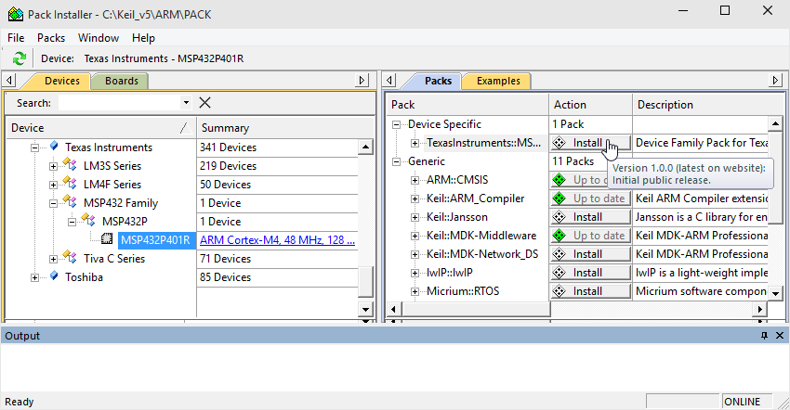

**MDK v4 Підтримка Спадщина**

# Project Development with MDK

## Loading a project into MDK



Project files are displayed in File Explorer with the Microvision icon, shown above. To load a project into MDK, do one of the following:

* Menu: Within MDK, select menu item Project->Open Project…, navigate to the project directory, and select the .uvproj file.
* File Explorer: double click on the .uvproj file.

Note that for all lab exercises, the Keil MDK project has been created for you, so that you can simply open and modify using Keil MKD as required.

Alternatively, you can use the mbed online compiler to create and develop a project (follow this link <http://mbed.org/handbook/mbed-Compiler> for details on how to do this). The online project can also be downloaded and ported to Keil MDK running on your local machine (see <http://www.keil.com/appnotes/docs/apnt_207.asp> for details on how to do this).

## Building The Project



Build the project using one or more of the following toolbar buttons (listed from left to right):

* Translate current file (e.g. compile or assemble)
* Build the target files whose source files have changed and create output file
* Rebuild all of the target files and create output file
* You may need to install the hardware support package for your platform. This can be done by clicking the package installer button in Keil MDK:



## Downloading the program IMAGE to the Microcontroller PROGAM memory (FLASH MEMORY)

Download the program to the MCU flash using one of these methods:

* Toolbar button: 
* Menu: Flash->Download
* Accelerator keys: Alt+A+D

Note: if the download fails, please check:

* The firmware has been installed on mbed board (hardware setup)
* Install Keil MDK5 legacy support (<http://www.keil.com/download/files/mdkcm510.exe>)

## Using the Debugger

Begin or end a debugger session using one of these methods:

* Toolbar button: 
* Menu: Debug->Start/Stop Debug Session
* Accelerator keys: ctrl+F5



Control the target program execution with the following toolbar buttons (shown from left to right above):

* Reset MCU
* Run program execution (F5)
* Stop program execution
* Step one line in program, entering a subroutine (F11)
* Step one line in program, executing and returning from a subroutine (F10)
* Step out of current function (ctrl+F11)
* Run to cursor (ctrl+F10)

Right-clicking on a line of code will bring up a context menu with various options, including:

* Setting and clearing breakpoints
* Adding a variable to a watch window
* Navigating to definitions or uses of symbols (functions and variables)

The View menu can be used to open different windows to help in debugging, including:

* Disassembly
* Symbols
* CPU registers
* Call stack
* Variable watch windows
* Memory windows
* System viewer (MCU and peripheral control registers)

# References

Getting Started with Keil uVision MDK:

www2.keil.com/docs/default-source/default-document-library/mdk5-getting-started.pdf?sfvrsn=0

Keil uVision MDK :

<http://www.keil.com/arm/mdk.asp>

Getting started with Keil uVision:

<http://www.keil.com/product/brochures/uv4.pdf>

Useful links to other user manuals:

<http://www.keil.com/arm/man/arm.htm>